GUIDELINES for the preparation of full-LENGTH PAPERs FOR THE 2nd RE-ConD’25 ınternatıonal conference

First A. Author1, Second B. Author2, and Third C. Author2

1 Institution of first author

2 Institution of second (and third) author

**Keywords:** Instructions, Historic Environment, Contemporary Designs, Guidelines

**Abstract**

**Introduction:**

This document provides information and instructions for preparing a paper to be included in the Proceedings of the RE-ConD’25 International Conference on Re-Evaluating Contemporary Designs in Historical Context. The paper should be written in English and can be written in Word.

**Developments:**

The first page is reserved for the title of the paper, the authors, affiliation, key words and the Abstract. Your abstract should be about 300 words; written using Times New Roman 12 and it must never exceed the first page.

**Remarks and Conclusion:**

The introduction must begin at the top of the second page. The proceedings will be edited in the e-Book using Portable Document Format (PDF). All the instructions as well as the Word template can be found in the website of the Conference **https://re-cond.org**

INTRODUCTION

The paper must be written following this instruction or using this Word template. The file has to be translated to Portable Document Format (PDF) before submission. Authors must upload their full paper in PDF file at the Conference website **https://re-cond.org**

The deadline for uploading the full paper posted on the website must be respected. The organizers do not commit themselves to include in the Proceedings any paper received later than this deadline.

* 1. Registration

The papers will only be published if the author participates in the conference. At least one of the authors must register and pay his/her registration fee before the deadline for their paper to be included in the final program of the Conference.

Once a paper has been uploaded, it will not be possible to edit the document.

* 1. Length of the documents

The paper including figures, tables and references must have a minimum length of 6 pages and must not exceed 12 pages.

* 1. Language

The paper must be written in English including the labels and legends in the figures (though in some particular cases the translation may be provided in the respective caption).

1. GENERAL SPECIFICATIONS

2.1 Paper size and margins

The paper size is A4 (21,0cm x 29,7cm) and the typing area is 16 cm wide and 24 cm high, centered in the page. The margin settings are given in Table 1. This document can be used as a template for writing the text.

Table 1: Margin settings.

|  |  |
| --- | --- |
| Margin | Size [mm] |
| Top | 28.5 |
| Bottom | 28.5 |
| Left | 25 |
| Right |  |

**2.2 Fonts, spacing, and styles**

All text, figure and table captions, equations, citations, and reference list should be written using Times New Roman font type.

The first page must contain the Title, Author(s), Affiliation(s), Keywords and the Abstract. The first line of the title is located 3 cm from the top of the printing box.

The second page must begin with the Introduction.

* + 1. Paper title

The title should be written centered, in Times New Roman font, 14 pt boldface in all capital letters. It should be single spaced if the title is more than one line.

* + 1. Authors

The author’s name should include first name, middle initial and surname. It should be written centered, in Times New Roman font, 12 pt boldface, 2,0 space below the title.

* + 1. Affiliation and contact information

Author’s affiliation should be written centered, in Times New Roman font, 11 pt, 2,0 space below the list of authors. A single space should separate two different affiliations.

* + 1. Keywords

Please, write no more than six key words, which will be used to compile the CD-ROM index. They should be written left aligned, in 11 pt, and the line must begin with the words; **Keywords** written in boldfaced. A 3,0 space should separate the key words from the affiliations.

* + 1. Abstract

The word **Abstract** must be set at the beginning of the first line, in boldface, separated in 3,0 spacing from the keywords, as shown in the first page of these instructions. **Introduction, Developments** and **Remarks and Conclusion** headings of the abstractshould be written in Times New Roman font 12 pt boldface. Text under these headings will be Times New Roman Italic font, 12 pt single spacing. The abstract should neither be too short nor exceed the first page.

* + 1. Main headings

The main headings should be written left aligned, in Times New Roman 12 pt boldface in all capital letters. There should be a 12pt space before and 6pt after the main headings.

* + 1. Secondary headings

Secondary headings should be written left aligned, 12 pt, boldface, with an initial capital for first word only. There should be a 12 pt space before and single spacing after the secondary headings.

* + 1. *Plain text*

The normal text should be written single-spaced, justified, using 12 pt in one column. The first line of each paragraph must be left aligned, second paragraph has to be indented 5 mm. There is no inter paragraph spacing.

* 1. **Equations and mathematical expressions**

A displayed equation is numbered, using Arabic numbers in parentheses. It should be centered, leaving a 6 pt space above and below to separate it from the surrounding text.

An example of an equation:

 (1)

where: *Ax* = shear strength along fibers, *Bx* = tensile strength perpendicularly to fibers.

* 1. **Figures, diagrams, and photographs**

All figures, diagrams and photographs (named as Figures) should be pasted into the text and numbered consecutively with Arabic numerals and captioned. Descriptions in the figures and their captions should be in English. Numbers proceeded by the word “Figure” (Bold), and captions should be placed under figures and centered in 10 pt Times New Roman font, with upper- and lower-case letters.

A 6 pt space should separate the figure from the caption, and a 12 pt space should separate the upper part of the figure and the bottom of the caption from the surrounding text.

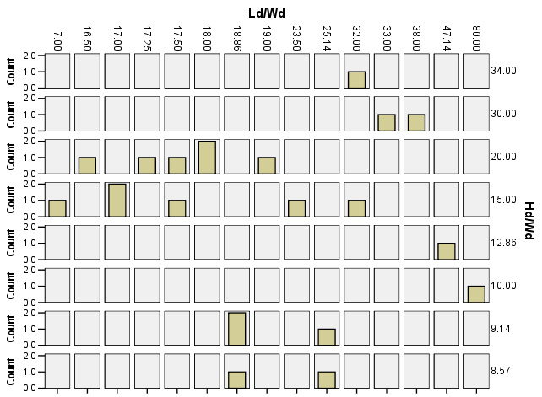

**Figure 1:** Figure example

* 1. **Tables**

All tables should be numbered consecutively and captioned, the caption should be 10 pt , upper- and lower-case letters. A 6 pt space should separate the table from the caption, and a 12 pt space should separate the table from the surrounding text.

1. REFERENCES

All references used in the text should appear together at the end of the paper and be listed by number within square brackets in the order in which they appear (see below). References should be quoted in the text by numbers [1, 2].

1. CONCLUSIONS

* Papers, translated to Portable Document Format (PDF), should be submitted electronically by using the conference website **https://re-cond.org**
* Deadline for the submission of papers on the website must be respected. Please consult the conference website for this information.
* At least one of the authors should register and pay his/her registration fee. Payment should be made before the deadline for “registration fee payment” in order that the paper will be included in the Conference Proceedings.

REFERENCES

[1] Mark, R. and E. C. Robinson. 1994. “Vaults and Domes”. In Architectural Technology up to the Scientific Revolution. Edited By R. Mark. The MIT Press, Cambridge, Ma.

[2] Atkinson, R. H., Amadei, B. P., Saeb, S. and Sture, S. 1989. “Response of Masonry Bed Joints In Direct Shear”. *J. Struct. Engr*. Asce, 115(9), Pp:2276-96.

[3] Bosnia and Herzegovina, in Britannica Online. http://www.-Eb.Com:180/Cgi-bin/ g?DocF=micro/79/88.Html, (2000).