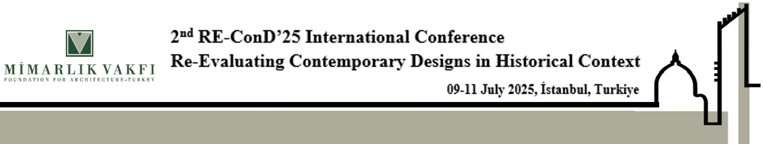
ABSTRACT TEMPLATE FOR
THE 2nd RE-ConD’25 ınternatıonal conference
First A. Author¹, Second B. Author², and Third C. Author²
¹ Institution of first author
² Institution of second (and third) author
Keywords: are limited to 6 key words
The abstract should focus on the necessity, concept, and criteria of the new design in heritage contexts and be structured in three main sections:

- Introduction
- Developments
- Remarks and Conclusion
All Abstracts are requested in English, written in Word and must not exceed 300 words single spacing and it must never exceed one page.
The writing font types are shown in the table below.
Title | Capital letter using Times new Roman font 14 pt boldface
Author(s) name(s) | Times new Roman font, 12 pt
Institutions | Times new Roman font, 11 pt
Key words | Times new Roman font 11 pt
Headings | Times new Roman font 12 pt boldface starting with capital letter
All abstract | Times New Roman font12 pt in one spacing.
Margins: | Top –28,5 mm, Bottom – 28,5 mm, Right & Left – 25 mm
The abstract should be presented in its final form, as it is intended to appear in the book of abstracts. Please check your typescript carefully to avoid any typographical and spelling errors and do not miss out any required details (e. g. author information). The abstract should be clear, aiming at giving a general overview of the paper. Submissions will be peer reviewed by the Scientific Committee of the Conference

Please submit the final abstract via the conference website https://re-cond.org

